**Claiming and Using Class Lab Machine**

*If you are using MacOS, make sure you have downloaded the latest version of Microsoft Remote Desktop, it should be version 10. After, power the VM back on and download the RDP file, click of the gear icon at the top of the Remote Desktop application and select Import from RDP file, navigate to the downloaded RDP file and select it. This should connect you to the VM. Allow a minute or two after the machine fully starts to connect and if this is still a problem, email as mentioned in FAQ’s #8 (at the last page of this document).*

1. Go to the following URL: [https://labs.azure.com/register/fxygpq2l](https://nam12.safelinks.protection.outlook.com/?url=https%3A%2F%2Flabs.azure.com%2Fregister%2Ffxygpq2l&data=05%7C01%7Cd.rudhramoorthi%40northeastern.edu%7Cd2b0b4408ff84ae00d0208da958767ff%7Ca8eec281aaa34daeac9b9a398b9215e7%7C0%7C0%7C637986706041794253%7CUnknown%7CTWFpbGZsb3d8eyJWIjoiMC4wLjAwMDAiLCJQIjoiV2luMzIiLCJBTiI6Ik1haWwiLCJXVCI6Mn0%3D%7C3000%7C%7C%7C&sdata=VQWuzIg4QnA%2Fmw2HaeGyUr6gJUZ9%2BXJK1wG5pUBGV3w%3D&reserved=0) using Chrome or Firefox
2. You should be prompted to login.
3. Enter your Office365 login for the username, this is your my.northeastern username with @northeastern.edu appended to it (do not use @husky.neu.edu).
4. Click Next

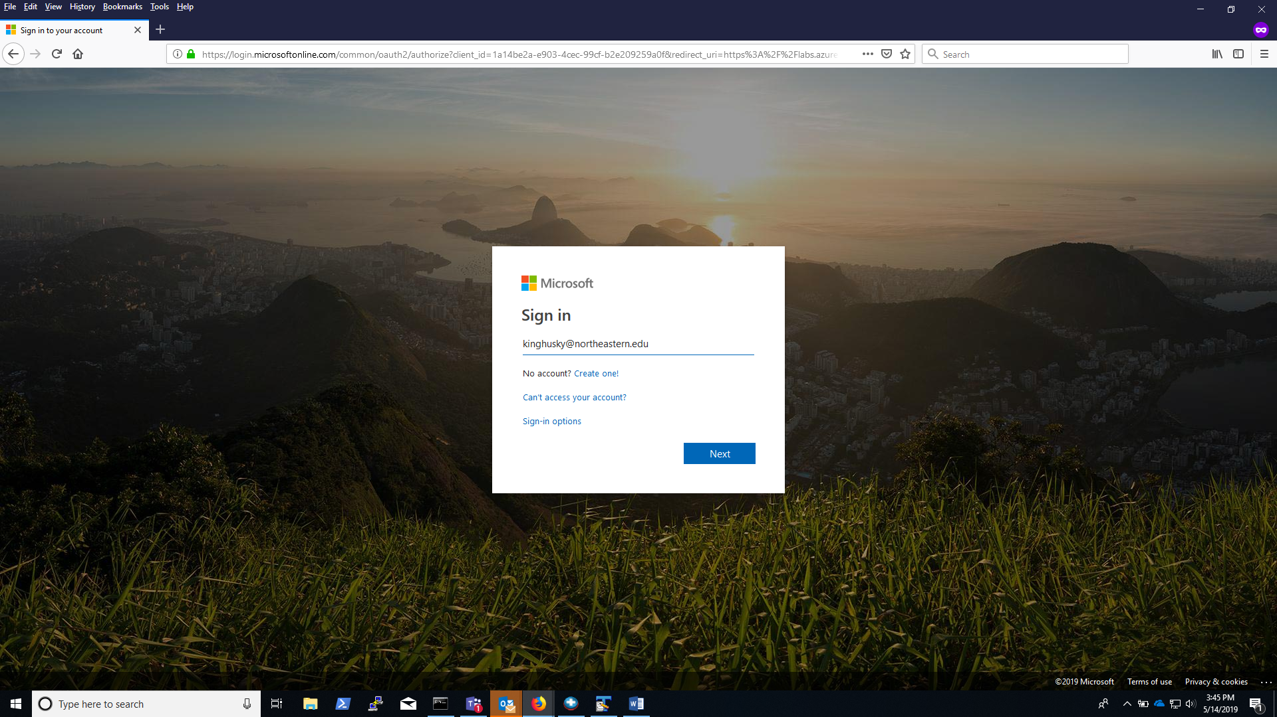

1. After entering your Office 365 login credentials you should be taken to the Northeastern login page. If you do not see the page below then go back and confirm that you appended @northeastern.edu to your username for your login
2. Enter your my.northeastern password, this should be the same password you use to access email
3. Click Sign In

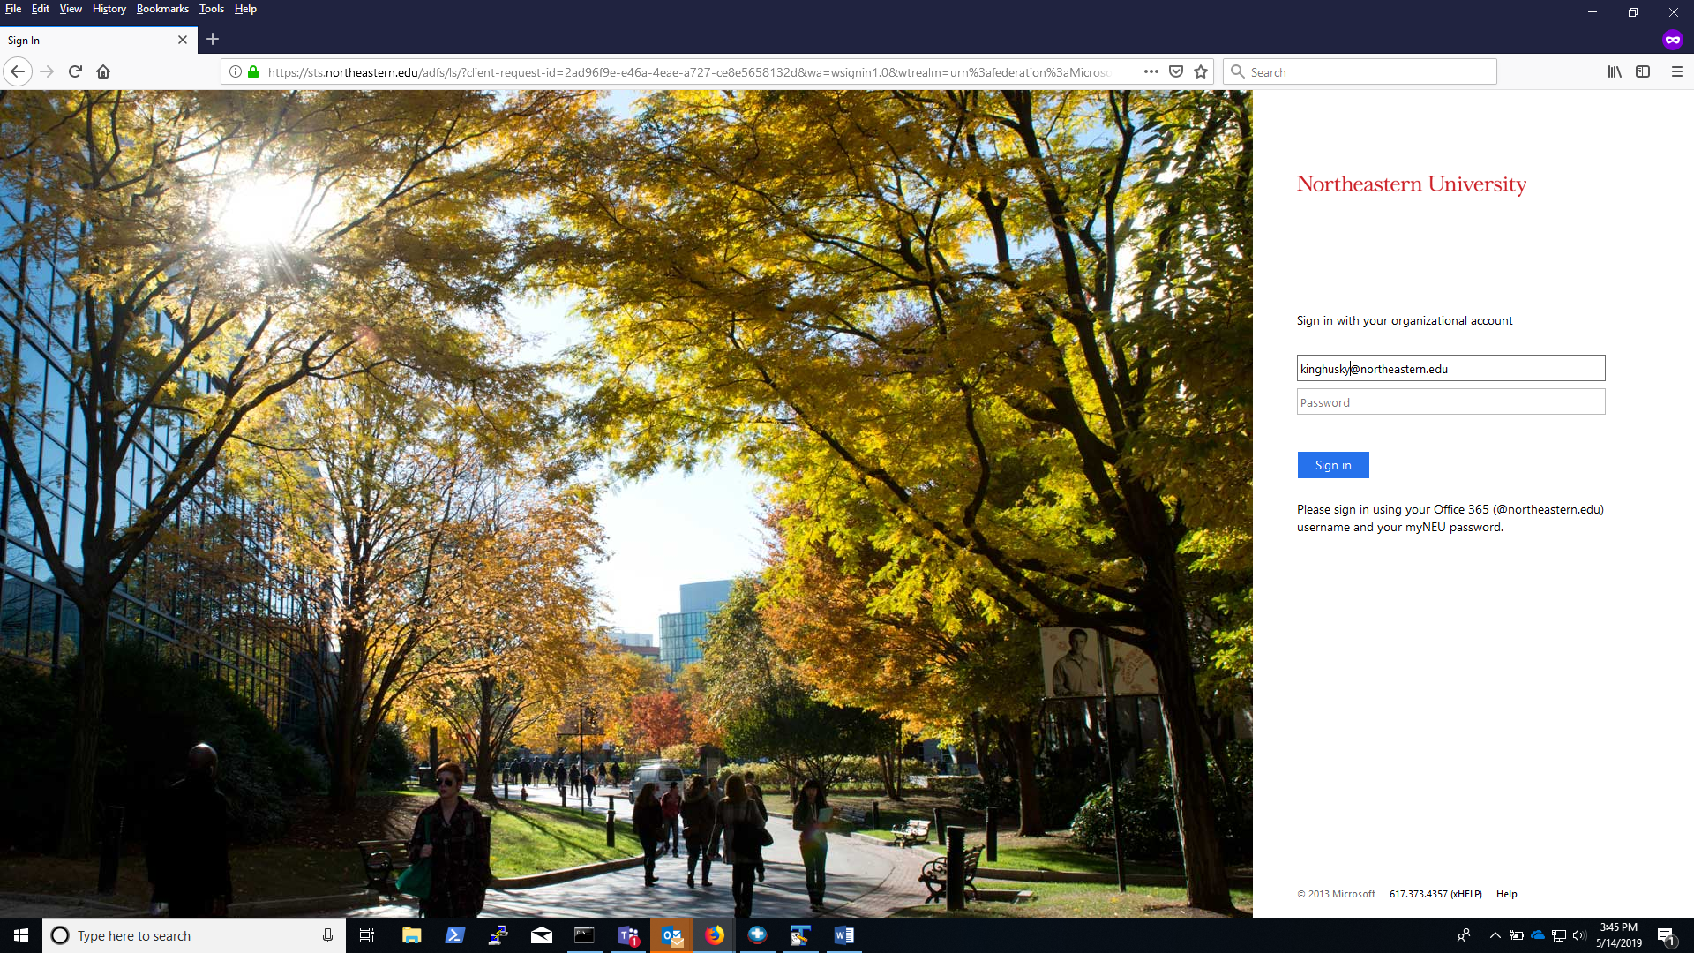

1. You should now see a page with the virtual machines that have been assigned to you, ***note that under the machine name it lists the hours used out of the total allocated***. If you are running low on hours please contact your instructor or and they will assign you more hours. Once you use the total hours allocated to the machine it will stop even if you are in the middle of using it.
2. Initially, your Azure Server will be in Stopped.

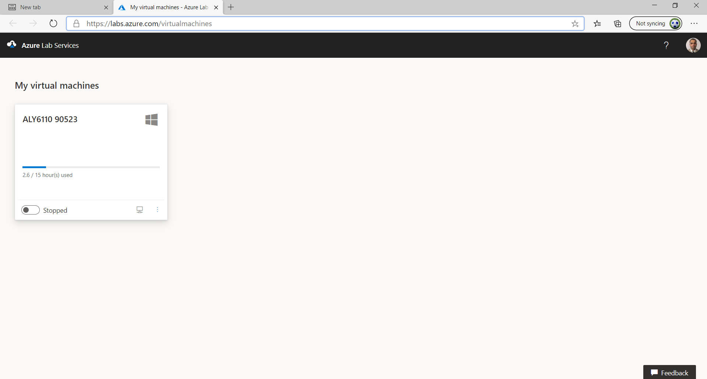

1. Push the switch to start the MS machine.
2. It should now say “Starting ”, it can take 10 minutes for the machine to fully startup.

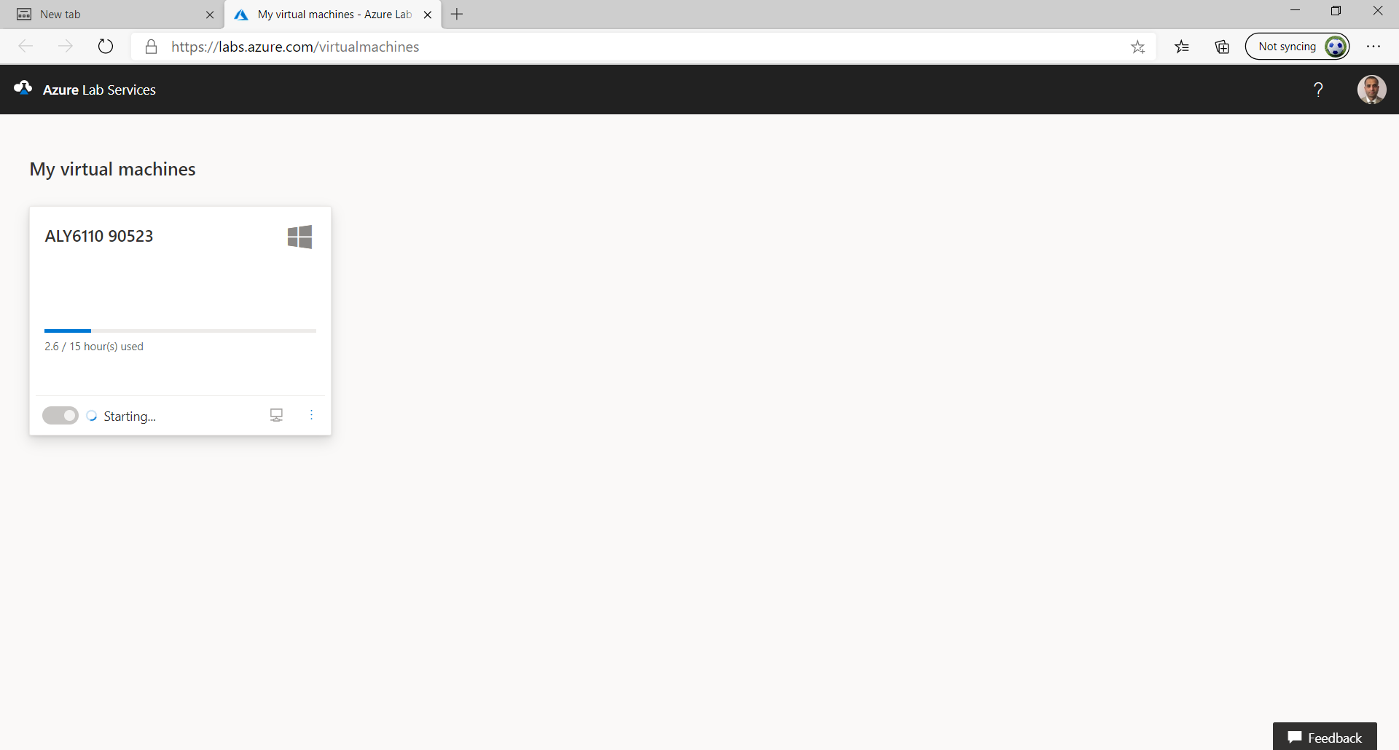

1. Once the machine fully starts up the Connect button will become active.

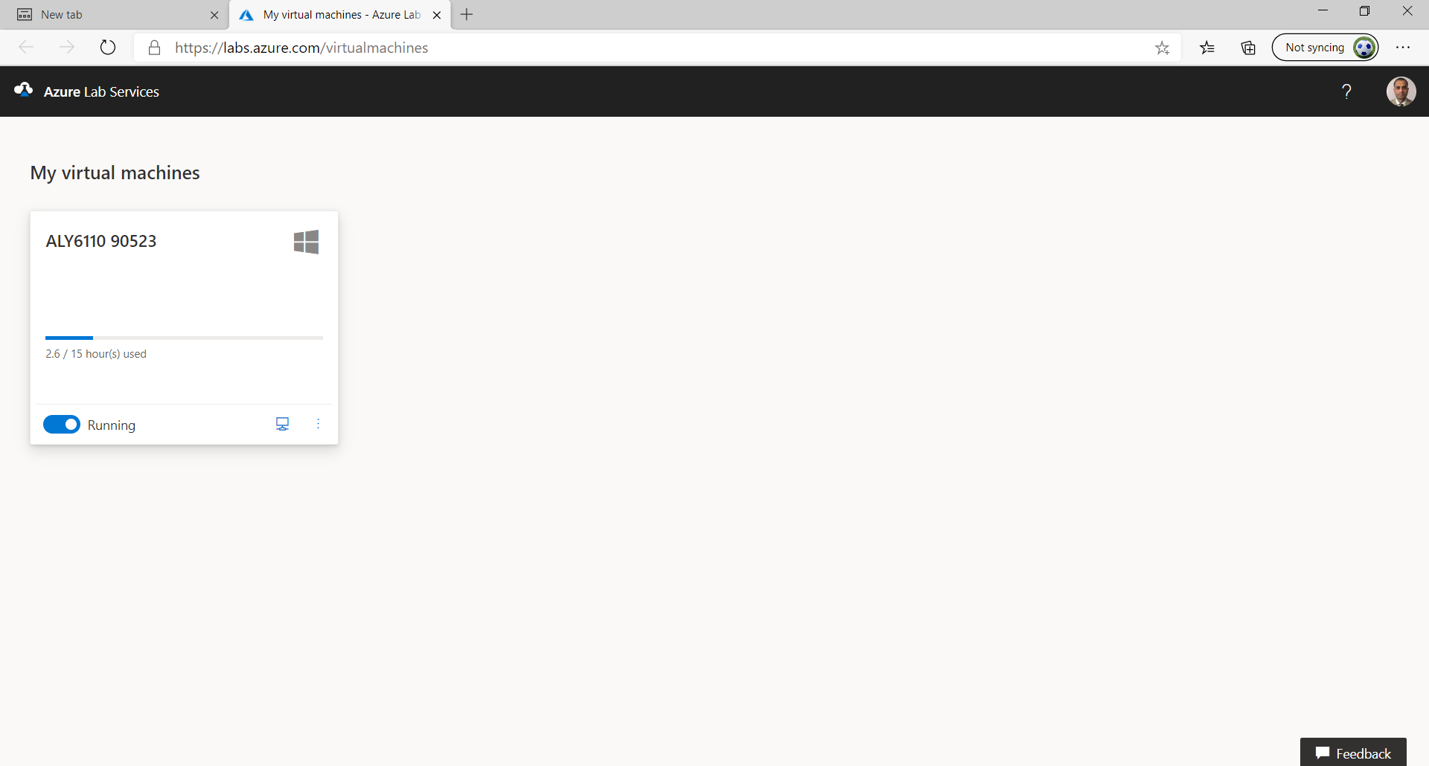

Connect Button

1. Click the Connect button to download the RDP file for connecting to your lab machine then run the file, if prompted choose the Microsoft Remote Desktop Client (Mac users may need to download this from the App Store) to open the file.

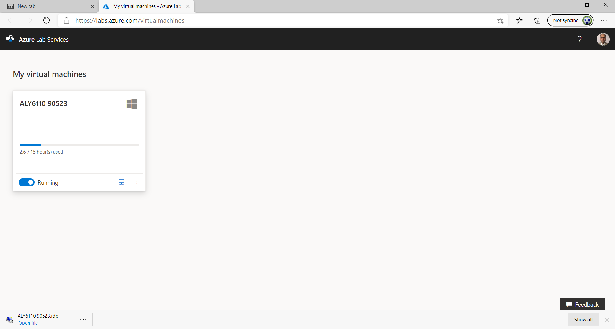

Downloaded RDP file

1. The Remote Desktop Connection client will open, click the connect button.

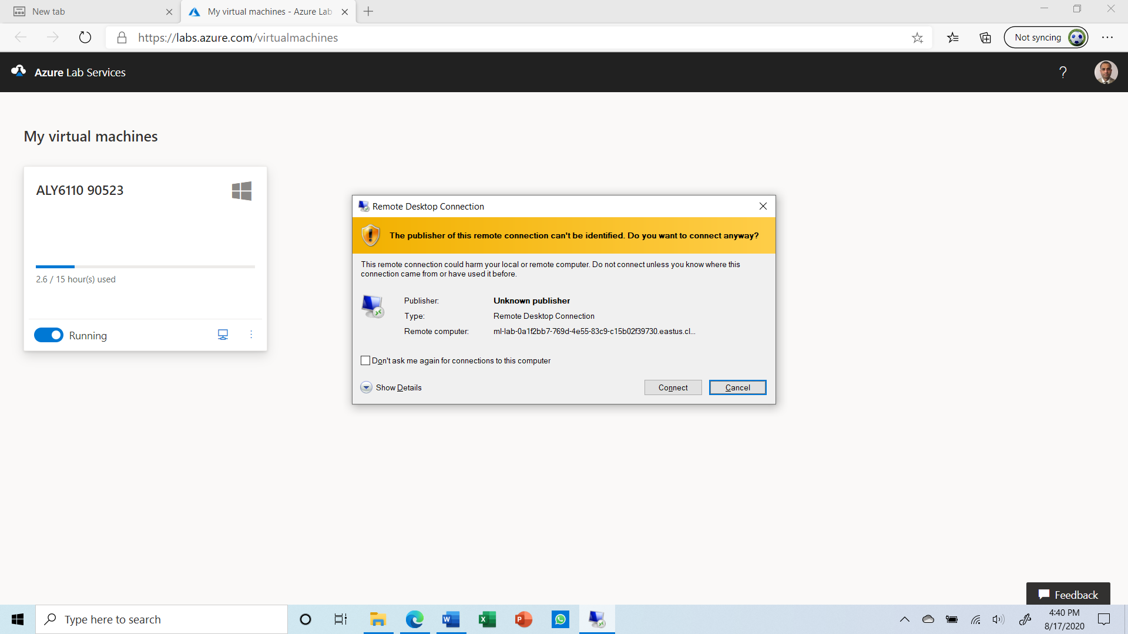

1. When prompted for the password for the Lab Machine enter ClassTest2 and click OK.

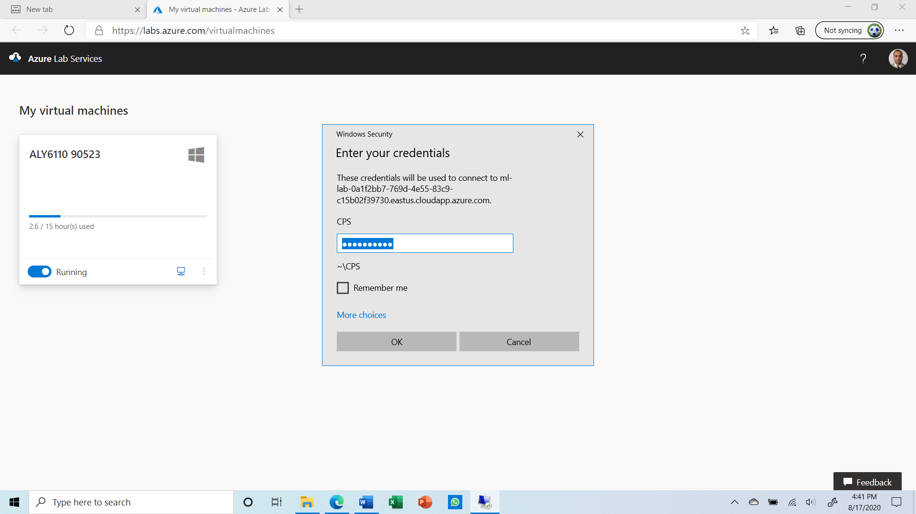

1. You will then be logged into the Lab Machine and should see the desktop below, for the class. Please note you should activate the Office software using your Office 365 username and password, reminder this is your my.northeastern username appended with @northeastern.edu. In order to receive an activation key for Project Professional you need to register with Microsoft’s Azure STEM program by using the shortcut on the desktop.



1. When you finish working with the Lab Machine for the day ***you must click the Stop button*** in the web interface that you used to start the machine. Until the machine is stopped it will continue to accrue hours, even if you shut the machine down via the Start Menu.

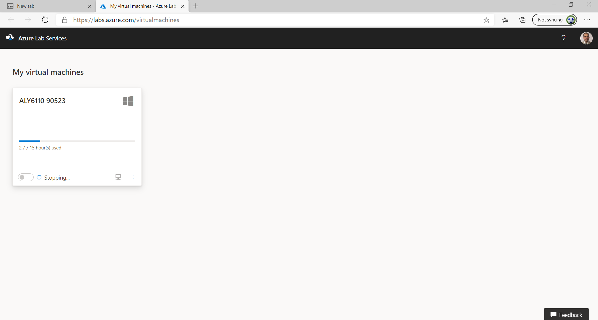

**Remember to Stop the Machine**

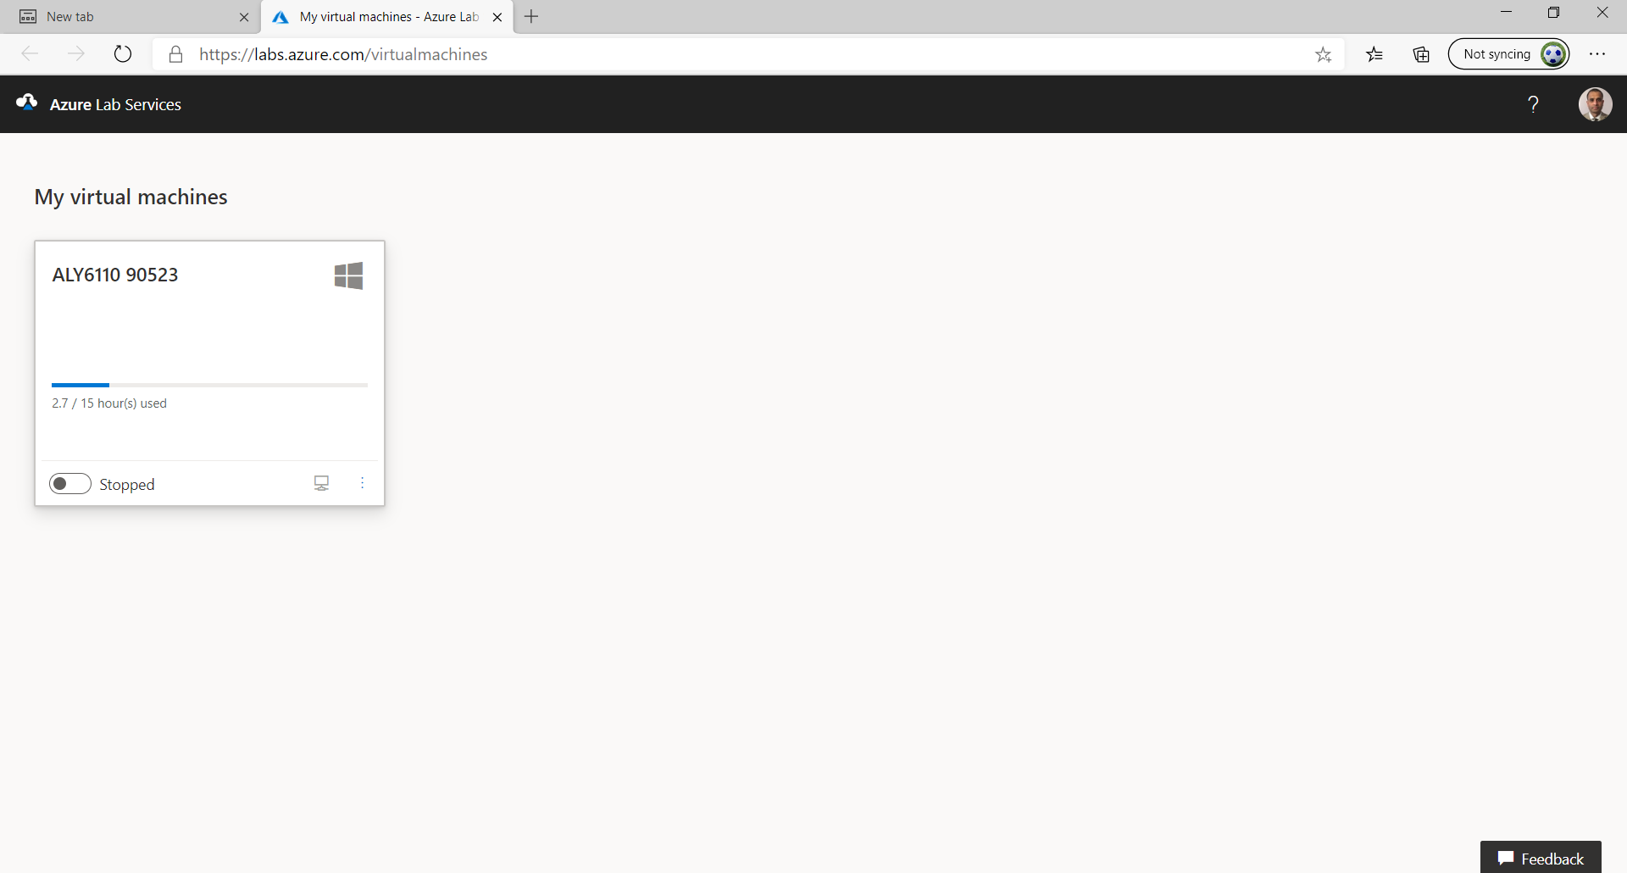

**FAQs/Troubleshooting**

1. **I am a Mac user and I do not see the Microsoft Remote Desktop Client in the store.**

Make sure your store location is set to the United States certain other regions such as China do not have this in their version of the Store.

1. **I am a Mac user and when I try to open the RDP file I downloaded it opens the Remote Desktop Client but does not connect.**

If this occurs in the Microsoft Remote Desktop Client, go to import connections and then browse to the RDP file you downloaded and import it. Then click on the icon for the computer in the client to connect.

1. **I have already claimed my machine how do I access it after stopping it?**

You can start, stop, and connect to your assigned machines by going to <https://labs.azure.com> and logging in with your Office 365 credentials, this is your username with @northeastern.edu appended to it.

1. **You are unable to start or connect to the Lab Machine or lose connection to the machine.**

This can be the result of running out of hours on the machine or a poor Internet connection.

1. **All the hours on your lab machine have been used even though you did not use the machine for that many hours.**

This usually is caused by not using the stop button in the web interface when you are finished using a machine for the day. Please note shutting down the machine via the Start Menu on the lab machine does not stop the machine and hours will continue to accrue, you must use the Stop button on the web interface when you are done using the lab machine.

1. **How do I get more hours assigned to my lab machine?**

If you need to have more hours assigned to your lab machine please contact your Professor or TA for your class.

1. **How can I transfer files between the lab machine and my personal machine?**

You can transfer files between your computer and the lab machine through the use of copy/paste functions on the computers.

1. **Who do I contact if my lab machine is not functioning correctly?**

Please email [azurelabs@northeastern.edu](mailto:azurelabs@northeastern.edu) for assistance in the email please include the following:

1. Your name
2. Contact information (phone number and good times to reach you)
3. Brief description of the problem
4. Class Information (Course name, meeting time, and Professor’s name)
5. **Who do I contact if I have exhausted allocated lab hours?**

Please email to **help@northeastern.edu** with **Subject: “**ALY 6110 CRN# Requesting for additional hours on Azure labs" and the below details

1. Your name

2. Contact information (phone number and northeastern email)

3. Brief description of the problem

      "Requesting for additional hours on Azure labs"

4. Class Information (Course number, CRN number, and Professor’s name)